HOLY LAND
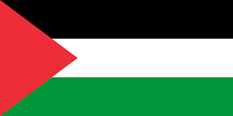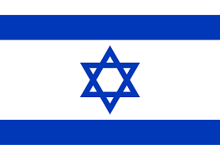
Background Information
The Christian community in the Holy Land, including Israel and the occupied Palestinian territories, faces immense challenges due to the ongoing conflict and historical tensions in the region. While Christians make up a small and diminishing percentage of the population, their presence remains vital in the land where Jesus lived, died, and rose again. Palestinian Christians, particularly in Gaza, the West Bank, and East Jerusalem, endure hardships from both political instability and societal pressures. Many churches have been affected by destruction or persecution, making daily life uncertain and difficult. The current war has brought immense suffering, with loss of life, displacement, and deep emotional and spiritual wounds.
Despite these hardships, the church in the Holy Land continues to persevere, embodying faith, endurance, and a longing for peace rooted in justice. Christian communities play a crucial role in offering humanitarian aid, advocating for reconciliation, and providing spiritual support to those grieving and suffering. Institutions such as Bethlehem Bible College play a key role in equipping local Christians for ministry and fostering theological reflection on faith and justice. Their Christ at the Checkpoint conference brings together global and local voices to discuss the struggles of Palestinian Christians and the call for a just peace. However, as the Christian population continues to decline, there is an urgent need for solidarity, prayer, and tangible support to ensure that the church’s presence remains a witness to Christ’s love and hope in a land of deep division and pain.

Bible Verse
You keep track of all my sorrows. You have collected all my tears in your bottle. You have recorded each one in your book. Psalm 56 v 8

Suggested Prayer Points
🙏 Pray for all those who are mourning and suffering.
🙏 Ask for peace but not at the cost of justice or suffering.
🙏 Pray God will raise up political leaders with integrity.
🙏 Pray for those who are angry with God, that He will meet them in their pain. (Sat 7)
🙏 Lift up churches, peacemakers, and aid workers serving in the region.
HOLY LAND
Prayer Activity:
This olive wood communion cup from the Holy Land
reminds us of Jesus' suffering on the cross.
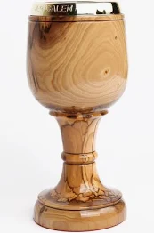
Olive wood is harvested from ancient trees, and is shaped through a slow and careful process, much like how God shapes His people through trials.

As we hold the cup, we remember that Christ does not abandon us in our suffering but walks with us and gathers our tears. Lament in solidarity with the suffering whether through words, silence or tears.

You may also wish to write a psalm of lament for the Holy Land.

