JORDAN
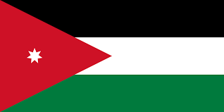
Background Information
Jordan has long been a place of refuge for Christians fleeing persecution from neighbouring countries, and its Christian population enjoys relative freedom. Christians make up less than 2% of the population and are represented by various Orthodox, Catholic, and Evangelical denominations.
Although Jordan is considered a moderate Islamic state, the Christian minority still faces challenges. Conversion from Islam to Christianity is illegal, and evangelism is restricted. Many Christians experience daily discrimination, and refugees seeking safety in Jordan often face additional hardships. Many refugees, especially those who fled from ISIS, have found support within Evangelical congregations but still carry deep trauma and uncertainty about the future.
Despite limitations, Jordanian Christians remain resilient, actively contributing to education, healthcare, and charitable work. Worship and praise have been particularly powerful in strengthening faith and bringing renewal to Jordanian Christians and those who have sought safety within its borders. Jordanian believers continue to worship, serve, and minister to others, embodying faith in a challenging context.
Bible Verse
"Come, let us sing for joy to the Lord; let us shout aloud to the Rock of our salvation."
— Psalm 95:1
Suggested Prayer Points
🙏 Let’s give thanks for how worship has reignited a sense of Jordanian Christian identity (Sat 7)
🙏 Pray for the perseverance and faith of Christians in Jordan, as they live under the challenge of restricted evangelism and face daily discrimination
🙏 Pray for Jordan Evangelical Theological Seminary (JETS), that students would be well equipped for ministry in such a challenging context.

JORDAN

Prayer Activity:

This tambourine represents joy in worship.

Write a prayer of blessing
for the country of Jordan
on the tambourine.

