Rekindling Hope
World Development Appeal 2022 – 23

Country South Sudan
Partner South Sudan Council of Churches
Project title Sustainable transitions from violence to peace in South Sudan
Amount £63,000

Project aim
Christian Aid has partnered with the Presbyterian Relief and Development Agency with the aim of strengthening the role of the church and other key actors in tackling conflict across Malakal County, South Sudan.

Partner organisation
The Presbyterian Relief and Development Agency is the arm of the Presbyterian Church of South Sudan and Sudan. Established in 1993 with a mission to carry out community based relief, rehabilitation and development activities that meet and address the overall social and physical needs of the people of South Sudan. Their work, functions and relations are driven, inspired and directed by a set of core values that come from their moral beliefs and Christian ethos.

Project background
It is widely recognised that faith-leaders and faith-led facilitation restores moral norms against violence moving people towards forgiveness and reconciliation. The church has been identified as unique in its ability to overcome distrust through neutrality. Their ability to have dialogue and remain neutral creates the opportunity for parties to air grievances constructively and increase their inter-communal understanding (which is necessary for lasting peace).

During the development of this project Christian Aid established there was an appetite amongst communities to seize opportunities to return to peace across communities and political movements.

An insight to project activities
With funding from the Presbyterian Church in Ireland’s World Development Appeal, Christian Aid and PRDA have been successfully conducting peace-building and conflict transformation activities in Malakal town, targeting 30 youths, 30 women, and 30 church and community leaders from various communities to become active peacemakers.
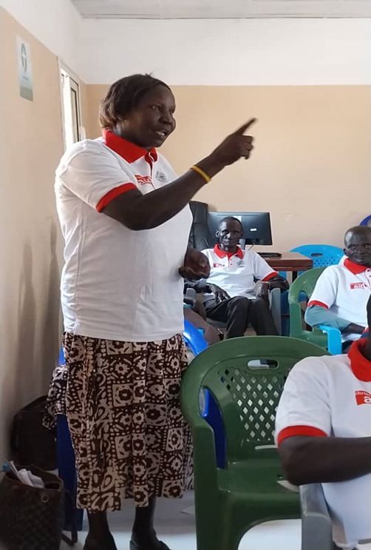
These peace agents have transformed, they are now reporting to be:
  - Empowered in their shift from passive conflict victims to active peace agents.
  - Equipped with skills for inter-tribal negotiation, mediation, and intra-tribal peace promotion.
  - Actively fostering awareness within the community about the benefits of peace, leading to a demand from groups to have a peaceful dispute resolution.
  - Bringing together church leaders, youths, and women to collaboratively find sustainable for peace and reconciliation in Malakal town, Upper Nile State, through inclusive and participatory peace-building processes.

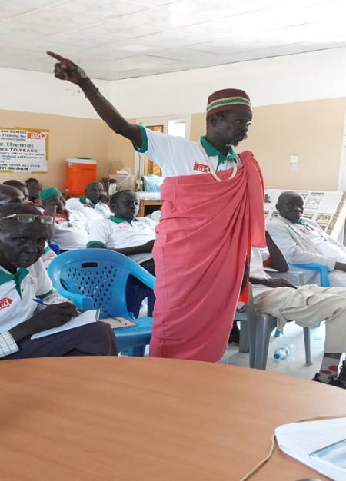
Christian Aid is delighted with the impact of this community led work so far, which most recently focused on the theme of ‘Doing what will lead to peace’ with the purpose of facilitating dialogue to engage diverse and divided communities in a constructive conversation, breaking down stereotypes and rebuilding trust.

As a result of dialogue in May 2024, participants gained an understanding of each other’s feelings, thoughts, and expressions, fostering empathy and contributing to a sense of unity and belonging. Participants are able to raise their voices in community meetings, with men listening and responding to the issues raised (as seen in the photographs in this report -taken May 2024).

Prayer request:
Realising peace in South Sudan will require sustained guidance, patience and involvement from both the church and civil society. Pray that the root causes of conflict will be addressed and that peace will soon prevail.
Country Haiti and the Dominican Republic
Project title Sustainable agriculture and nutritional security for conflict and climate affected communities
Partner Jesuit service for migrants
Amount £63,000

Project aim
This project aims to build community cohesion, combat extreme poverty and social exclusion in the communities where thousands of displaced families are having to rely on survival strategies in order to survive – with makeshift shelters and stitched together clothing.

Partner organisation
The Jesuit Service for Migrants was created in 1999 by the Jesuit Refugee Service and are an international organisation founded by the Jesuits in the context of violence and repression in Africa and also in Latin America. They currently operate in several countries to accompany, serve and defend the rights of refugees and displaced people.

Project background
This project was created to bring hope, build community cohesion and combat extreme poverty and exclusion within communities in the North-East Department of Haiti, where people – mainly Haitian migrants and their Dominican-born descendants – have found themselves returned to Haiti, and struggling to survive following their forcible deportation from the Dominican Republic by the Dominican Government. The International Organisation for Migration report that as of June 2024, Haiti has 578,074 displaced people. This is a 60% increase over the preceding three months. Widespread gang violence and political instability from the start of 2024 fuelled this surge, and in the North-East Department, displaced people now constitute 11% of the population.

Haiti has one of the highest levels of food insecurity in the world and the World Food Programme states that as of March 2024, 4.3 million Haitians (nearly half of Haiti’s 11.8 million population) do not have enough food to eat. Host communities in the North-East of Haiti are struggling to provide for these new residents, as they are themselves are living in an area where extreme poverty still exists as a direct result of the impacts of natural disasters (extreme flooding in 2022 & 2023, and both hurricane Grace, and a 7.2 magnitude earthquake in 2021). This has increased the strain on residents, and social tensions have risen in the area.

This project is supporting both community residents and returnees of all ages to manage and prevent conflict from arising, and to facilitate meaningful, peaceful and respectful integration.

Project activities
Since the launch of this project significant progress has been made across the three target municipalities, Ouanaminthe, Capotille, and Ferrier.

Thanks to the help of the Presbyterian Church in Ireland, Christian Aid and local partner SJM – Jesuit Service for Migrants – Frontier Solidarity have, to date worked with a total of 2,064 direct beneficiaries, and a total of 6,192 indirect beneficiaries.

Activities completed to date include:
- 3 working sessions between 120 civil society actors and local authorities were conducted, focusing on developing strategies to address environmental protection across the 3 municipalities.
- The civil status office in the municipalities of Ferrier, Ouanaminthe, and Capotille was supported to provide birth certificates to 3,000 vulnerable paperless individuals.
- More than 1,280 migrants returning or leaving were registered at the official border point of Dajabòn.
- 140 migrants were assisted with food, transport, accommodation and health kits.
- 8 co-ordination meetings (including 15 people per person) were carried out for this work, including 1 meeting with particular interest groups (commerce, agriculture, environmental protection and management of natural resources), and on how to manage the living situation at the border.
- World Refugee Day (June 20, 2024) was celebrated with 70 participants.
- World Environment Day was celebrated with 50 participants.
- Reforestation days in Ouanaminthe and Capotille were carried out with 100 participants.
- A clean-up day on the banks of the Massacre River was carried out with 50 participants.
- Material and information about the project was distributed to 100 civil society actors and state organisations from the 3 municipalities which improved its visibility.

This project is bringing hope to community residents while also strengthening their resilience and capacity to advocate for climate justice at a community level. This is having a positive impact in the lives of participants whose main income source is charcoal production. Together our partners are also having an impact by improving the capacity of migrants, returnees and community residents to effectively manage and prevent the identified migration-related tensions.

Challenges
There were several unforeseen challenges that caused delays in the progress of this project, including political social unrest at the beginning of 2024 in the North-East Department, particularly in Ouanaminthe. This included the blocking of streets, absence of traffic, and the robberies of public and private institutions including the project partner, SJM. Therefore, this project is being extended by 6 months, to 31st March 2025, to ensure the quality of the work and the achievement of the set objectives. This will allow the project to finish all current activities and complete the majority of the remaining activities.

Prayer request
Please continue to pray for peace in this region, may Christian Aid’s partners The Jesuit Service for Migrants - Frontier Solidarity who are working in difficult situations, work with hope and the knowledge that the hand of the Lord is in their lives and their missions for peace, unity, dignity.
Country Democratic Republic of Congo
Project title Humanitarian Assistance Project for Internally Displaced People and Vulnerable Families
Partner The Ecumenical Office for Development Support
Funding allocation £22,500

Project aim
This project had an aim to bring hope and support for 200 households affected by the ongoing conflict and humanitarian crisis in North Kivu province in Nyirangongo Territory, DRC by supporting them to meet their basic needs and access psychosocial support.

Partner organisation
The project was delivered together with Christian Aid’s local partner Bureau Œcuménique d'Appui au Développement (BOAD – The Ecumenical Office for Development Support). They are a non-profit, non-governmental development organisation that has been operating in the DRC since October 1997, on the initiative of local civil society actors from both the Church and the lay world.

BOAD is a member of the ACT Alliance and a long-term implementation partner of Christian Ad working mainly in the following sectors; sustainable development (food security, good governance and conflict management), humanitarian assistance and rehabilitation (humanitarian aid, cash, essential items) and protection and psychosocial support.

Project background
Since 2022, the eastern region of the Democratic Republic of Congo (DRC), in particular North Kivu, has been gripped by a devastating conflict that has intensified and become increasingly complex over time, with the potential to reach unprecedented levels in the province.

It is estimated 1.65 million people are internally displaced in the region, with 186,422 displaced directly as a result of this recent conflict. 58% of these IDPs are female, and 14% are children under 5. Although the majority of the internally displaced persons (IDPs) are residing in host communities, 46% of displaced people are surviving in displacement sites, many of which have already been operating beyond their capacity for several years as a result of conflict around Goma.

Activities completed to date include:
With funding from the Presbyterian Church in Ireland World Development Appeal, Christian Aid’s local partner Ecumenical Development Support Office (BOAD) provided emergency support to over 200 families (1,260 people) displaced by fighting now living in Kanyaruchinya and Don Bosco makeshift displacement camps around Goma.

As this project aimed to provide cash assistance in the first instance, Christian Aid DRC and BOAD identified two mobile telephone companies with experience in cash transfers through the ‘mpesa’ system, allowing the immediate mobile transfer of funds to families.

The transfer of funds to individuals who are directly in need of humanitarian aid empowers them to determine and meet their most pressing needs, boosting the effectiveness of response, and allowing households to determine their own priorities and live with dignity, rekindling their hope for a future with dignity and choice.

The transfer of funds also allows local markets and businesses to continue functioning, and in this situation with the support of our partner BOAD supplies of food and non-food items will be pre-stocked to ensure once funds are available to families they are able to make purchases locally.

Esther’s Story
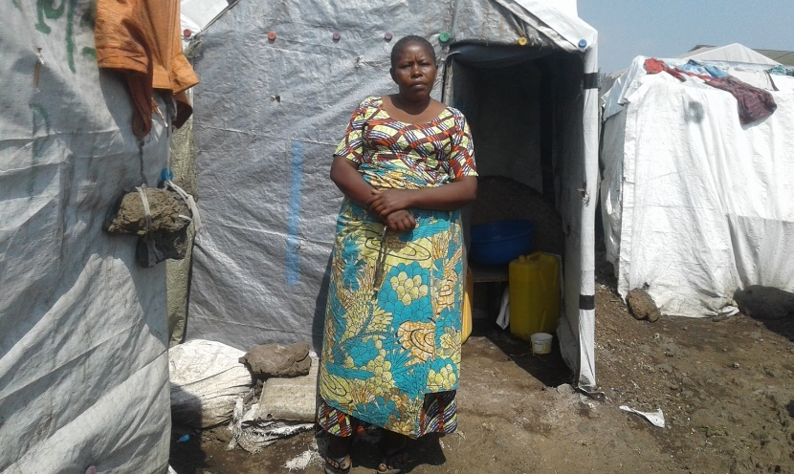
Caption: Esther (not her real name) standing outside her shelter in Don Bosco makeshift displacement camp on the outskirts of Goma, North Kivu Province, eastern DRC.
Credit: Paluku Mudogo Angelus/Christian Aid.

“I farmed and had almost everything for free. I also sold maize and bean flour.”

Widowed mum of six Esther (not her real name) lived in Rutshuru town in North Kivu province, eastern DRC.

However, fighting between the militant group M23 and government forces forced Esther’s family to flee the town on the back of a pickup truck in search of safety in May 2022. As Esther explained, it was a harrowing ordeal.

“We were very crowded in the truck. We had no water or food,” Esther said. “We didn't bring anything with us. The only concern I had was to save myself and my family,” she added.

Ongoing conflict in Eastern Congo has intensified in recent years, in particular since a ceasefire expired in late December 2023, forcing more than 1.7 million to flee their homes with many now living in displacement camps to escape the fighting.

It took Esther’s family a day to flee south to reach Goma, the capital of North Kivu province. They have since lived in Don Bosco makeshift displacement camp on the outskirts of the town in a tent made of tarpaulin.

With funding from the Presbyterian Church in Ireland’s World Development Appeal, Christian Aid’s local partner Ecumenical Development Support Office (BOAD) provided emergency support to over 200 families (1,260 people) who have been displaced by the ongoing conflict in North Kivu province and are now living in Kanyaruchinya and Don Bosco makeshift displacement camps around Goma.

With the support she received, Esther was able to buy food as well as clothes for her children. In addition, the cash also helped Esther to set up a small business to support her family.

“If I had not received this cash assistance, I would not have the money for my small business. I sell corn and cassava flour,” she said.

“With the income from the sale of flour, I buy food such as beans and amaranth grain,” she added.

Around 24,000 people who have fled the ongoing fighting between M23 and government forces are living in the Don Bosco displacement camp today. While the emergency support provided by our local partner was a lifeline for Esther’s family and helped her to get back on her feet, as she explained, like other families in the camp, they still face many challenges.

“My family only eat one meal each day in the evening. We suffer from hunger,” Esther said.

“There is no medical care in the camp and our shelters are deteriorating day by day,” she added.

For Esther, attending church helps her to cope in the face of adversity.

“I attend church on Sunday’s to pray and sing. Yes, prayer is important to me, it comforts us in our difficulties.”

Esther said that she worries that the fighting might one day reach the camp and that her family will be forced to flee once more. She said that she hopes and prays that there will peace someday and when that day comes, she will be able to return home.

“I have hope that the war will end one day and I will return to my village.”

Prayer request
Pray for peace and that those affected by displacement would not lose hope for their futures. Pray that the daily needs of households would be met, and that families are able to return to their homes without fear.

Country Sierra Leone
Project title Supporting forcibly displaced families as they rebuild their lives and livelihoods
Partner Sierra Leone Council of Churches
Funding allocation £63,000

Project Aim
This project was developed with an aim to restore peace, dignity and sustainable livelihoods for displaced women who have been victims of displacement and have lost their land and livelihoods to a multinational palm oil company.

Partner agency
The Council of Churches in Sierra Leone (CCSL) has a mission to promote the prophetic ministry of Jesus for the benefit of communities. They have a vision empowered by the Gospel for life, truth, justice and peace.

As an umbrella organisation for seventeen member churches and ten affiliates, they speak with a united voice, promoting peace, justice and development. They are well placed in their work as they are rooted in the communities they serve and operate at all levels of society to mitigate hunger, poverty and disease.

Project activities
With the support from the Presbyterian Church in Ireland, this project is continuing and has expanded to include both the Ngorbahun and Sorbeh Grima communities in the Kpanga Chiefdom, these communities are playing the role of the host by supporting displaced by the conflict and evictions around the plantation.

This generous support of the Presbyterian Church in Ireland has enabled Christian Aid Ireland and the Council of Churches in Sierra Leone to promote and distribute agricultural tools including hoes, shovels, rakes, groundnut seeds and cassava stems and financial capital to support business start-ups and Village Savings and Loans Associations. The level of interest in the VSLAs has been more than expected, with some groups needing to split into two to accommodate more members, and in locations where Christian Aid and the CCSL have been unable to accommodate the numbers of those interested in joining – encouragement and guidance for new groups will be established with supervision from ‘parent groups’ established through this project. These new groups have begun with an empty box, but a commitment from their members to contribute their personal savings as their start-up funds in the VSLA Box.

Christian Aid is delighted to report that the welfare of families is changing as a result of this funding from the Presbyterian Church in Ireland. Some families are experiencing financial stability for the first time, and many women are gaining respect in their respective communities. Women are also raising their voices to boldly speak out, defend their rights, and advocate for peace.

Psychosocial support has been provided to displaced women in the Malen chiefdom – helping them to recover from traumatic experiences. Training on peacebuilding and non-violent communication in conflict resolution has been provided, and many participants have expressed a determination to act as ‘agents of peace’ in their communities. The local radio station in Malen has also supported the peacebuilding agenda by hosting and broadcasting shows on this topic.

To date this funding has directly reached 378 individuals (364 female and 14 male) aged 18-60. Indirectly this project has reached 3,600, and an additional 3,250 through mass media.

Christian Aid is delighted to report that the welfare of families is changing as a result of this.
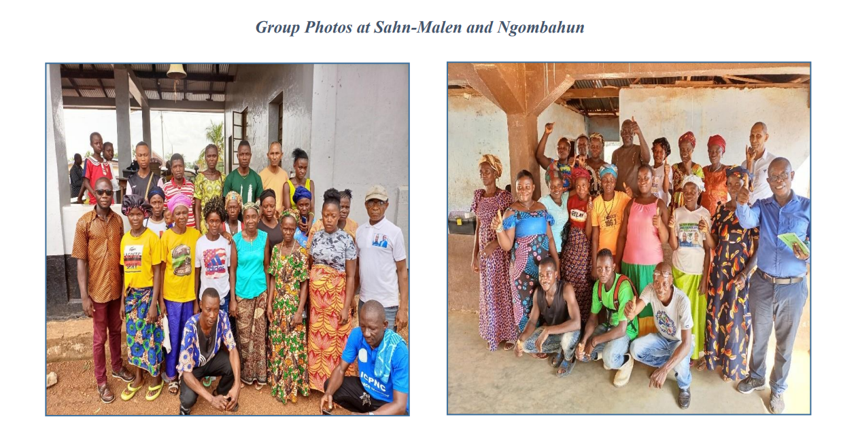

Prayer request:
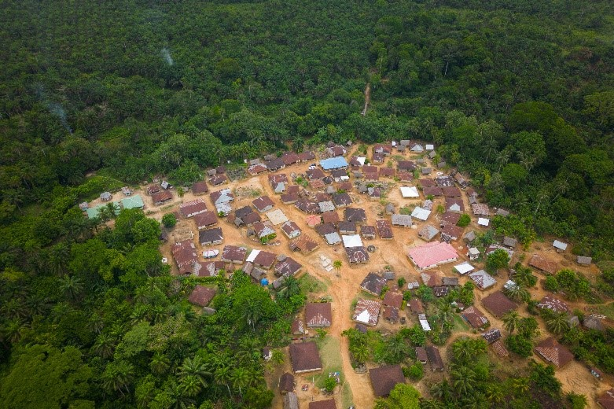
Please pray with us as we give thanks for the transformation we’re witnessing in these communities. Pray that people continue to be hopeful, joyful and enthusiastic for their futures. Pray also that communities affected by displacement in Sierra Leone will continue to be welcomed into their host communities allowing families to integrate and live full lives.

