Starting from Scratch
World Development Appeal 2023 – 24

Country Sierra Leone
Project title Supporting forcibly displaced families as they rebuild their lives and livelihoods
Partner Sierra Leone Council of Churches
Funding allocation £52,333

Project Aim
This project was developed with an aim to restore peace, dignity and sustainable livelihoods for displaced women who have been victims of displacement and have lost their land and livelihoods to a multinational palm oil company.

Partner agencies
The Council of Churches in Sierra Leone (CCSL) has a mission to promote the prophetic ministry of Jesus for the benefit of communities. They have a vision empowered by the Gospel for life, truth, justice and peace.

As an umbrella organisation for seventeen member churches and ten affiliates, they speak with a united voice, promoting peace, justice and development. They are well placed in their work as they are rooted in the communities they serve and operate at all levels of society to mitigate hunger, poverty and disease.

Project background
In 2011 a large multinational company took on a 50 year lease of a large area of land in the Malen Chiefdom in the Southern province of Sierra Leone with the aim of creating a palm oil plantation. Many people faced great pressure to hand over their land, resulting in a loss of livelihood, dignity and homes – for some people they lost everything.

Christian Aid developed this project to restore peace, dignity and sustainable livelihoods for some of those displaced women and their families. Supporting them as they rebuild their lives and livelihoods in their new host communities.

Project activities
This project was the focus of the World Development Appeal materials in 2023-24 and was funded during that financial year through the Rekindling Hope World Development Appeal.

This additional contribution of funding for another year will support Christian Aid’s strategic plan to strengthen the Sierra Lone Council of Churches in their work, enabling them to work in additional communities, supporting even more displaced households with training, Village Savings and Loans Association start-ups, agricultural inputs and tools to support peace and reconciliation between community members.

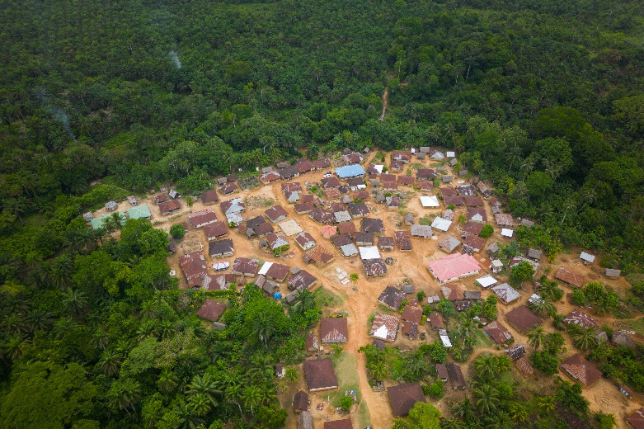
Prayer request:
Please pray with us as we give thanks for the community transformation we’re already witnessing through this project. Pray that this work continues to reach those who are vulnerable, and may it bring joy and opportunity for the entire community.

Country Haiti and the Dominican Republic
Project title Sustainable agriculture and nutritional security for conflict and climate affected communities
Partner Jesuit Service for Migrants
Amount £52,333

Project aim
This project aims to build community cohesion, combat extreme poverty and social
exclusions in the communities where thousands of displaced families are having to rely
on survival strategies in order to survive – with makeshift shelters and stitched together
clothing.

Partner organisation
The Jesuit service for migrants was created in 1999 by the Jesuit Refugee Service. They are an international organisation founded by the Jesuits in the context of violence and repression in Africa and also in Latin America. They currently operate in several countries to accompany, serve and defend the rights of refugees and displaced people.

Project background
This project was created to build community cohesion and to combat extreme poverty and exclusion in the communities within the North-East Department of Haiti.

Project activities
Since the launch of this project significant progress has been made across the three target municipalities, Ouanaminthe, Capotille, and Ferrier.

Thanks to the support of the Presbyterian Church in Ireland through the Rekindling Hope World Development Appeal in 22-23, Christian Aid and local partner the Jesuit Service for Migrants have to date been able to work with a total of 2,064 direct beneficiaries, and a total of 6,192 indirect beneficiaries.

We look forward to continuing this work into 2026.

Challenges
There were several unforeseen factors that caused delays in the progress of this project from last year, including political social unrest at the beginning of 2024 in the North-East Department, particularly in Ouanaminthe. This included the blocking of streets, absence of traffic, and the robberies of public and private institutions including the project partner, SJM. Therefore, this project is being extended to an expected date of the to 31st March 2026, to ensure the quality of the work and the achievement of the set objectives.

Prayer request
Please continue to pray for peace in this region, may Christian Aid’s partners The Jesuit service for migrants and Frontier Solidarity who are working in difficult situations know the hand of the Lord is in their lives and their missions for peace, unity, dignity.

Country South Sudan
Partner Presbyterian Relief and Development Agency (PRDA)
Project title Strengthening the capacity of women and youth in peace building in Malakal and Juba, South Sudan
Amount £53,330

Project aim
Christian Aid has partnered with the Presbyterian Relief and Development Agency with the aim of strengthening the role of the church and other key actors in tackling conflict across Malakal County, South Sudan.

Partner organisation
The Presbyterian Relief and Development Agency is the arm of the Presbyterian Church of South Sudan and Sudan. Established in 1993 and has a mission to carry out community based relief, rehabilitation and development activities that meet and address the overall social and physical needs of the people of South Sudan. Their work, functions and relations are driven, inspired and directed by a set of core values that identified them on their moral beliefs and Christian ethos.

Project background
Christian Aid and the Presbyterian Relief and Development Agency understand that the
use of positive role models within conflict affected communities is very effective in negotiating for sustainable peace. This project is training church leaders who are highly respected in their communities on how to use their prophetic voice to offer moral guidance on reconciliation and peacebuilding through their church services and community encounters to influence and change attitudes toward peace, meaning that those who are starting from scratch are appreciated, respected and welcomed into communities.

Project activities
This project has continued to operate with a backdrop of an escalation of local and national violence. The conflict in Sudan continues to exacerbate the fragile security of South Sudan, resulting in more refugees needing assistance, as they attempt to settle in communities with fewer available resources, making the work carried out by this project even more crucial.

Prayer Point:
Please pray for a restoring of peace in South Sudan, pray that those trained in peacebuilding and reconciliation will continue to promote lasting peace among displaced and host communities, support those who are vulnerable and provide a space that is safe and welcoming for all members of the community.

