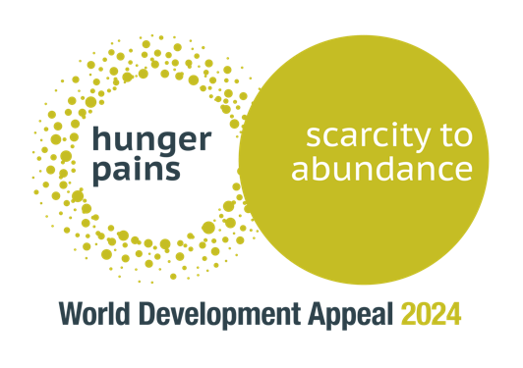

Children’s Address / Bees

- Does anyone here like honey?
- Which creatures make honey?
- Have you ever seen a bee-hive?

They are full of noisy little bees who have a very special and busy job. Have you ever noticed that they’re always doing the same thing – they focus on searching for lovely plants and flowers which are full of nectar, they visit them, take the nectar and return to their hives to make honey.

Today I want to talk to you about something that’s happening with beehives far away in a country called Honduras, in South America (point that way <-…)

The problem:
In Honduras some families are struggling to have enough food to feed everyone three meals a day. Imagine if you could only eat breakfast and then not again until the next day? It's a big problem.

But bees are part of the solution!

The solution:
Our friends at Christian Aid are working to unite families and friends to build new beehives. So that lots of families and communities can enjoy yummy honey!
Together the communities are learning how to take care of their new bees, repair and build their beehives using lots of natural materials like wood.

Bees are wonderful and make lovely sweet honey,

But why do you think the beekeepers in Honduras need to be really careful when they try to collect the honey from their beehives?
Yes, that's right - bee stings!

I think they will need lots of things a protective suit, gloves and goggles.

World Development Appeal:
Presbyterian churches all over Ireland are being encouraged to think about others, and give some of our money to help these communities become great beekeepers.

We want to raise money through the World Development Appeal to buy suits, gloves, goggles and pay for expert local beekeepers to spend time in communities showing and teaching them how best to look after their bees.

But the most important thing these families will learn is how to safely collect their delicious honey. Because once it has been collected - and everyone has had a little taste… these friends and families work together to put the honey into jars, label them, and sell them at their local markets.

Once the honey is sold – everyone involved has more money to spend on food, their homes, school uniforms, new jars for their next honey collection, and they even make some savings in case they need extra money in the future. It’s giving people a real chance to have a better life in their communities.

Bees have so much potential, but did you know a single bee can’t run a hive on their own?

They work so well together: each bee has it's own role to play - there is a queen, worker bees, guards, nurse bees who look after the babies and bees that help build the hive. They all have a part to play in making the hive a success.

What you can do:
We also all have a part to play as part of the Church. In the bible it says "you are the body of Christ, and each one of you is a part of it." (1 Corinthians 12:27)

Just like the bees all work together to make honey - Jesus wants us to work together to be his body here on earth.

That means we can be his hands to help someone in need, or his mouth to say a kind word to someone.

Jesus wants us to be part of his team to do good things in the world and share his love with others. You could pray for families in Honduras, or raise some money to help them.

Let’s pray:
Heavenly Father,
Today we thank you for our families and friends, and the teams we are a part of.
We pray for our global neighbours in Honduras, that you would protect them as they work hard to care for bees – so that families can have three full meals each day. Give them the courage and guidance to continue working together with hope for the future.
Help us to be full of goodness, kindness and love for others as we journey through our days and the week ahead.
Amen.

