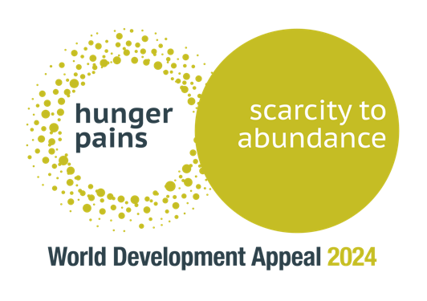

Children’s Address / Food insecurity

Boys and girls,

Today one of the things we are thinking about is - a big word - ‘food insecurity’ - which simply means that there are lots and lots of boys and girls, just like you, who don’t have enough food to eat, or who might have some good food one day and then not enough the next day! Can you imagine if your breakfast this morning was the only food you would eat today?? No sweeties at Sunday school, no roast dinner for lunch, no tea or supper or snacks. Do you think you would be hungry? Or maybe even ‘hangry’ (hungry and angry…)

Since we are talking about food let’s talk about vegetables. Who likes their vegetables?

What is the favourite veggie in church this morning? (Speaker could have a bag of vegetables to show - maybe including some more obscure examples!)

Show of hands…

Peas?
Carrots?
Broccoli?
Sweetcorn?
Any others?

I wonder have any of the mums and dads ever found themselves saying something like; ‘you need to eat those vegetables, there are boys and girls going hungry around the world, don’t you know…’

I always thought that was a bit of an unfair way to get me to eat my veggies, but of course it is true.

Did you know that 1 in 10 families around the world don’t have enough food to eat? (that can be a bit hard to understand)

That’s 150 million children - boys and girls like you - who don’t get to eat what they need?

That’s not fair, sure it’s not?

As Christians, we have a very special calling to help people around the world, and here at home, who are in need. Why?

- Because God has made each and every person in the world - we are all made by him, loved by him - the Bible says we are made in God’s image, we are his Masterpiece - which means each and every person is incredibly special. WOW - every person we meet or will never meet is hand-made by God himself!! How sad it must make God, who is our Father, to see any of his children sad and hungry like this!

- But we also help because he has told us to.

Christians are to ‘speak up for those who cannot speak for themselves’ (Proverbs 31:8)

Christians are people who ‘loose the chains of injustice (or unfairness)’ Isaiah 58:6

Christians are people who see someone in need and help them, because God’s love is in us (1 John 3:17)

So what can we do?

- We can start with ourselves and be really, really thankful for our food - thankful for farmers and shops and factories and mums and dads and grandparents who make it for us. If you don’t already say Grace at mealtimes - this is a really useful way to remind us to be thankful to God for our food.

- Someone once said that if we are ever a bit overwhelmed by big problems like hunger we should ‘look out for the helpers’, and celebrate the good news stories.

So we can celebrate that there are people right across the world, churches just like this one who are busy loving their neighbours, sharing their food, standing up and shouting out loud that ‘IT’S NOT FAIR’ and who are working together to make sure boys and girls around the world have enough food. Part of the way we can celebrate is by giving a little bit of our money to the Presbyterian Church’s World Development Appeal which this year is helping families in Rwanda, and around the world, to make sure they have enough food for today and tomorrow and the future!!! Maybe you can chat over your table this lunchtime about how you could give to support those helping and making a difference?!

- And of course we can pray - which we will do now. God is in charge and we want to ask him to use his people to make the world a more ‘just’, a more ‘fair’ place. We want to ask him to make us into even more thankful people, and to be especially near and close to those who don’t have enough food today. May your Kingdom come, Lord Jesus.

