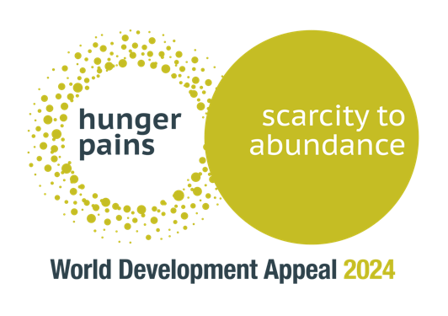

Church service announcement

The World Development Appeal this year is entitled: “Hunger Pains: Scarcity to Abundance.”

We do not know the pains of hunger — but this is a reality across the world today where many live below the poverty line.

How can we help?

We can give to the PCI’s World Development Appeal to supply the necessary funds to support Tearfund projects in Rwanda, Malawi, Bangladesh, Uganda and Burkina Faso and Christian Aid projects in Honduras, the Democratic Republic of Congo, Sierra Leone and also Burkina Faso.

The lead project this year is in Rwanda — where Tearfund is working through the Presbyterian Church in Rwanda to bring not only practical help but also the gospel.

Rev Joseph Muhire (PC Rwanda): “We are asking the Presbyterian Church in Ireland to pray for us. Especially, we want the church to grow. We want that the good news will reach to many people and we want them to come to Christ. Please pray for the church in Rwanda to have everything needed to reach to those people in the community.”

We commend Rev Joseph to your prayers and we ask that you give generously to the Lord’s work in Rwanda and to the other eight projects listed above through the World Development Appeal. Please make use of the appeal envelopes where you will find more information about the work.

If using the VIDEO…

You will see Reverend Joseph now introduce this short video highlighting the work in Rwanda…

https://vimeo.com/966912552

