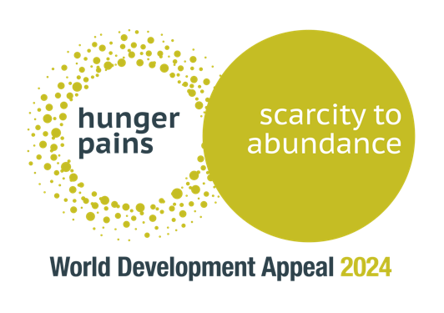

Additional projects supported by WDA 2024 through partnership with Tearfund

Churches Bringing Change
An opportunity to equip the local church to be a change-maker in farming communities, ensuring families have enough to eat
Each of these projects is reducing food security and increasing the resilience of communities, and at the heart of each project is the local church, acting with vision and passion to transform the lives of the people around them. Alongside our ‘lead’ project in Rwanda, here is a summary of the remaining projects where your partnership will make a difference.

Malawi
This project, working with local project Eagles in Bakala district, empowers local churches in farming communities to together meet the interconnected challenges they are facing - deforestation, climate change and food insecurity. Training will be provided for 300 ‘Lead Farmers’ who will disseminate knowledge in a wide range of areas, including crop resilience and profitability. Self-help groups will be established to provide wider training in value addition and the benefit of collective approaches, as well as a level of community support and encouragement. Training will be delivered in water and sanitation across the community. Throughout this all, the church will use its presence and connections to engage the most vulnerable in the area.

Bangladesh
In the Patuakhali district of Bangladesh communities are trapped in cycles of poverty due to regular flooding, degradation of soil and water and increasingly extreme weather. To address this local crisis, Tearfund is working through World Concern Bangladesh and local churches in 50 of the most vulnerable communities, aiming to increase resilience and improve economic stability. Training will be delivered to farmers in flood resistant farming and to communities in disaster preparedness so that the next disaster doesn’t restart the cycle of poverty once again. The issue of gender-based violence is of particular concern; churches will be equipped to respond and tackle this issue and work at empowering women in income-generating activities.

Uganda
In parts of Northern Uganda half the population live below the poverty line. Tearfund has partnered with the Church of Uganda in the Teso region to address food insecurity. Local experts will set up demonstration farms to model climate-resilient practices. Communities will be trained in business development and market access, with 250 beehives available to farmers to kick start a diversified income. Across three parishes, churches will lead on training and participation, not just on farming, but on a wide range of issues identified by the community as areas for growth and change. Central to this is the understanding that each person has God-given gifts and resources, and each person’s contribution is needed for a community to flourish.

Burkina Faso
In Burkina Faso, 86% of the population rely on subsistence farming to provide their basic needs. Tearfund has partnered with Office de Développement des Églises Évangéliques (ODE) to introduce self-help groups as a model for change in 10 communities. Focusing on sustainable agriculture, financial management and entrepreneurial skills, self-help groups become a key driver of mindset change, training and community development. Incomes grow, livelihoods are diversified and communities learn to support themselves and each other.

